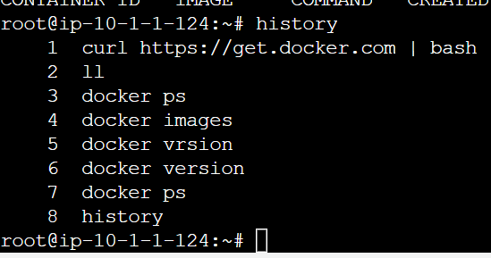

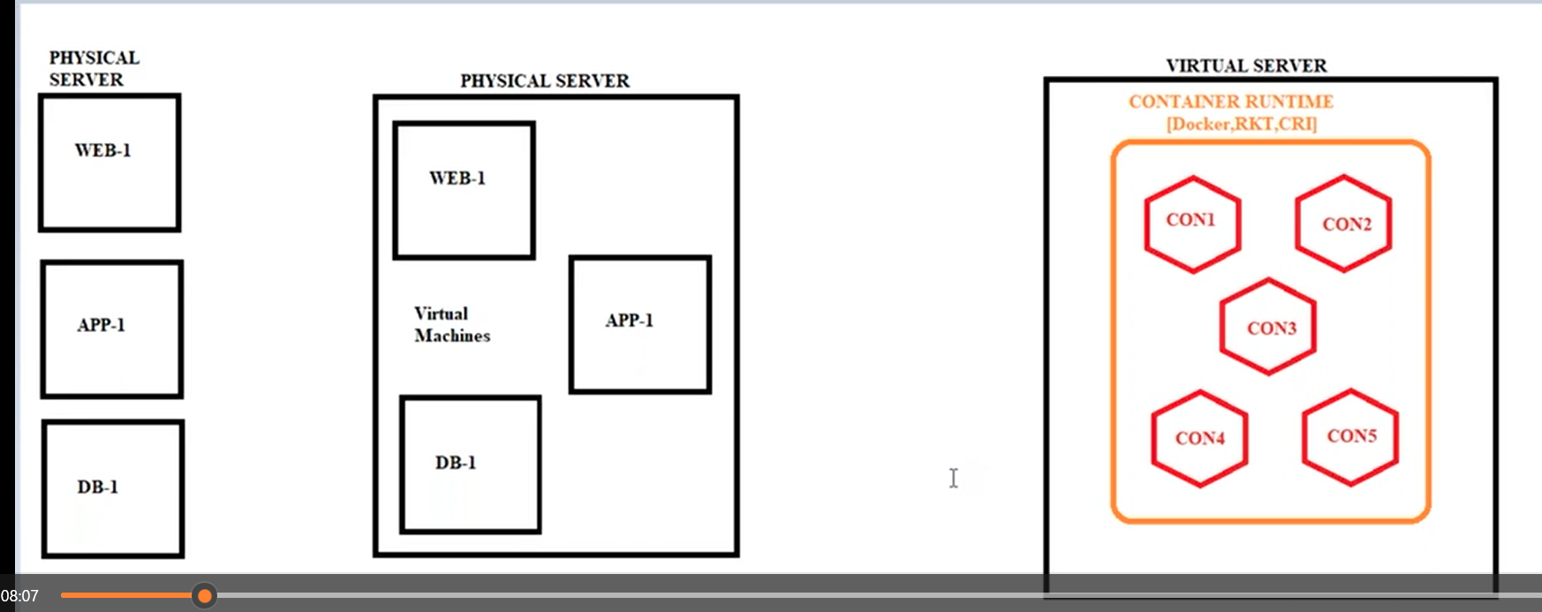

Vertiualization vs containerization

Docker architecture:

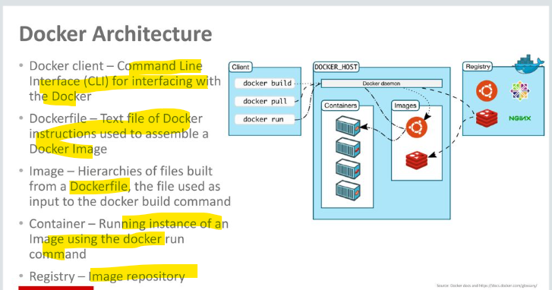

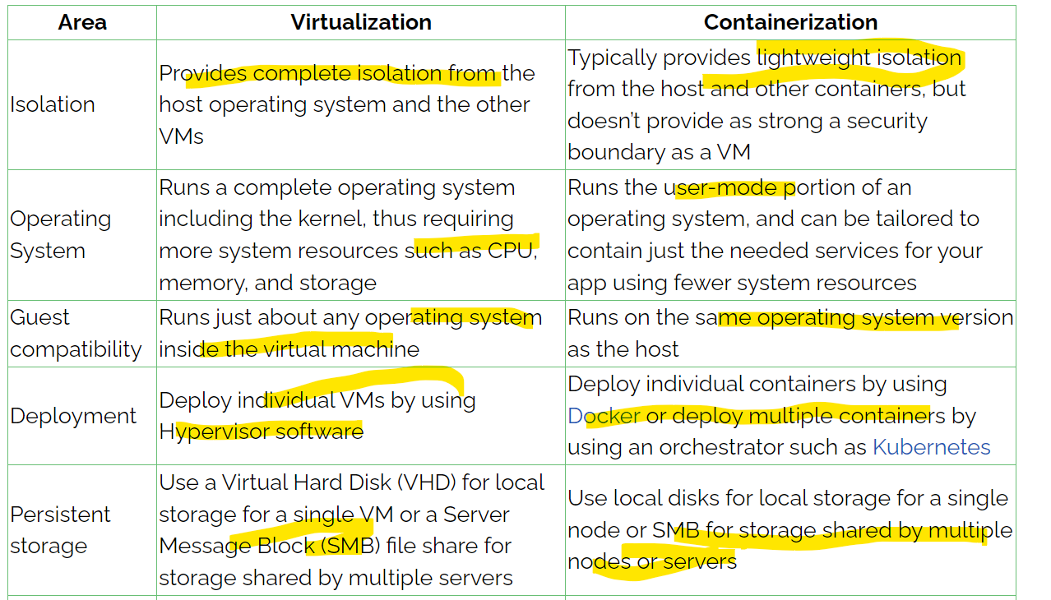

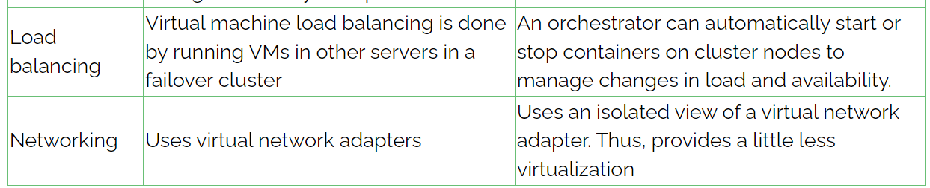

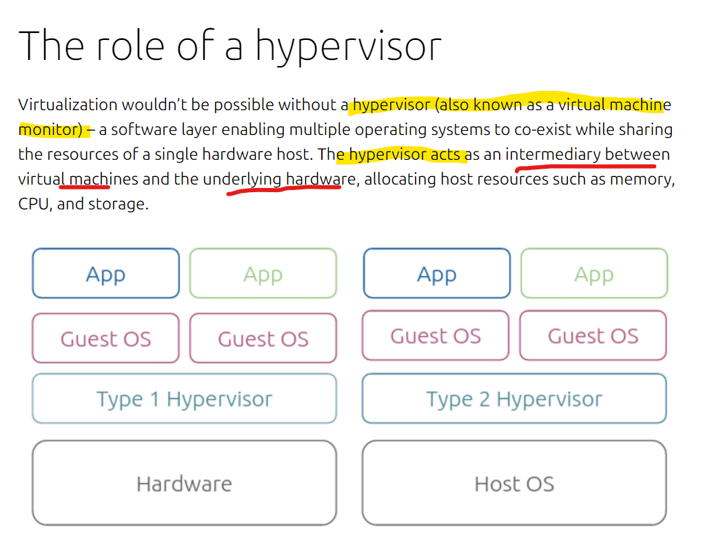

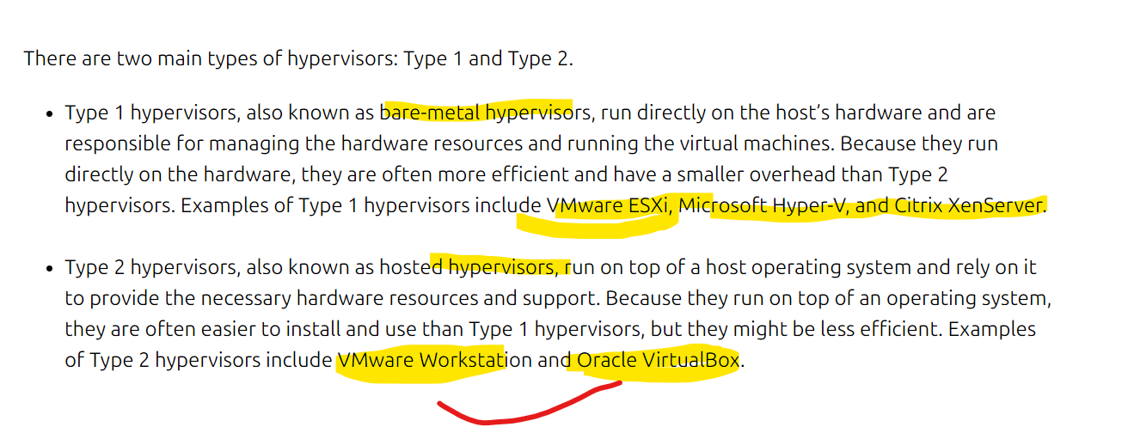

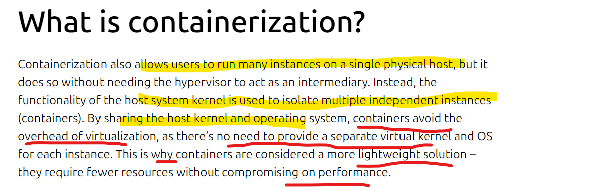

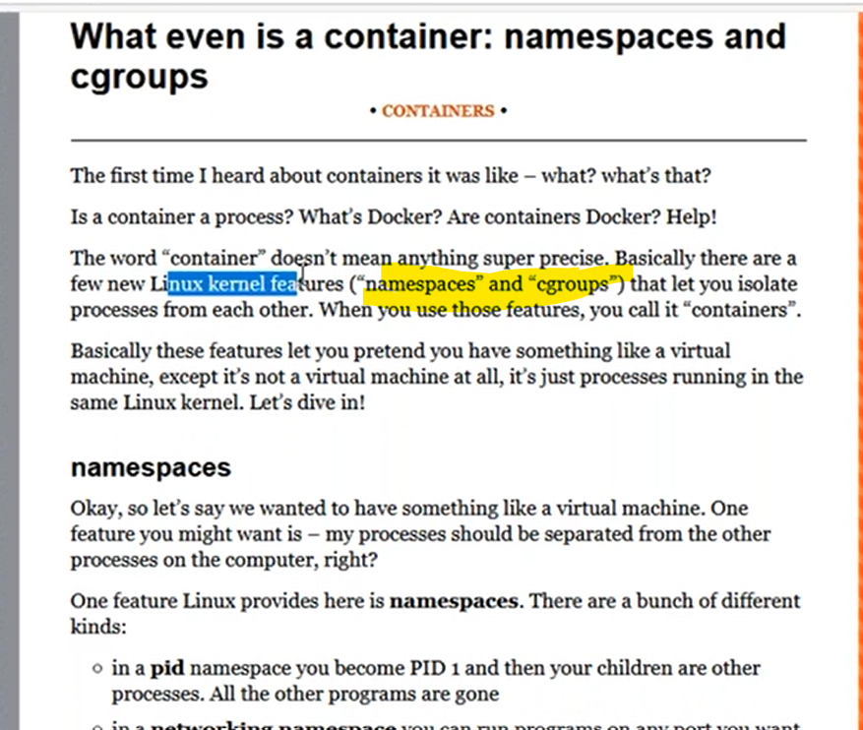

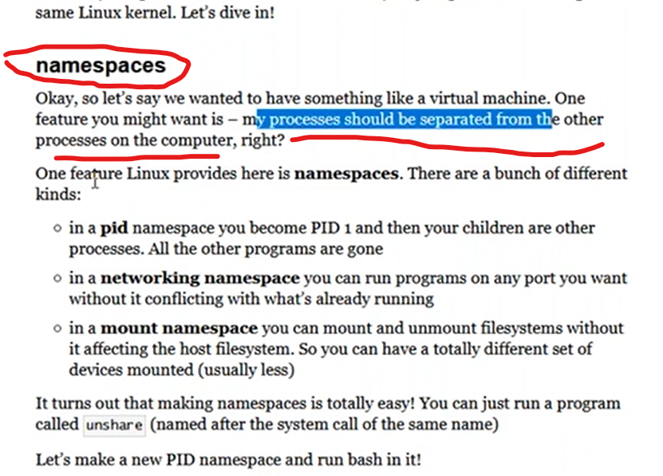

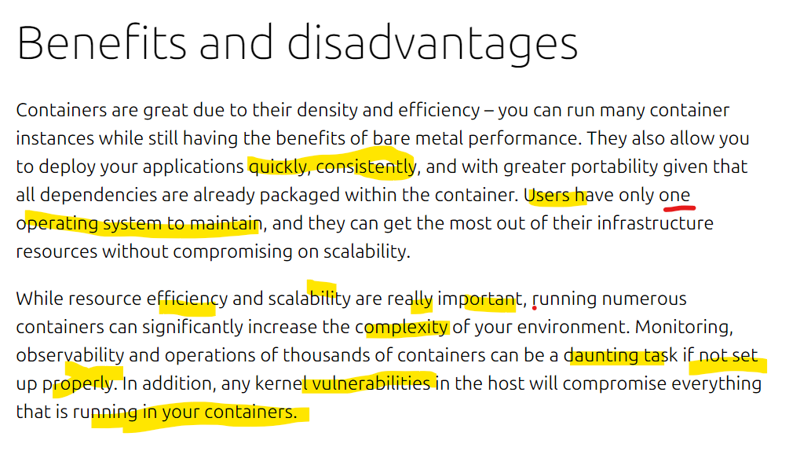

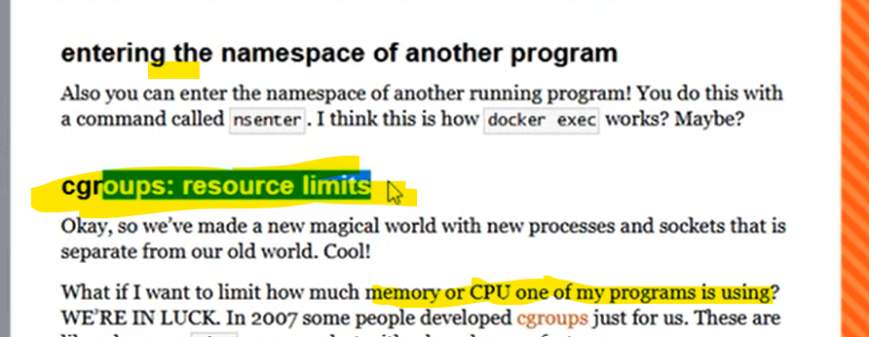

Process cpu and memory limit like providing docker resourse limit

Docker install

1. curl <https://get.docker.com> | bash
2. docker images
3. 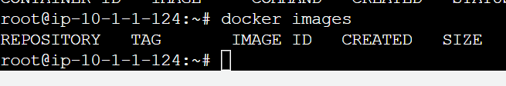
4. docker ps
5. 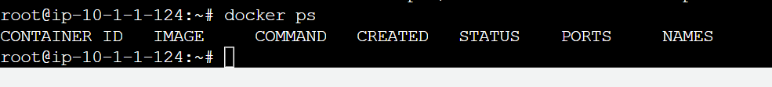
6. docker version

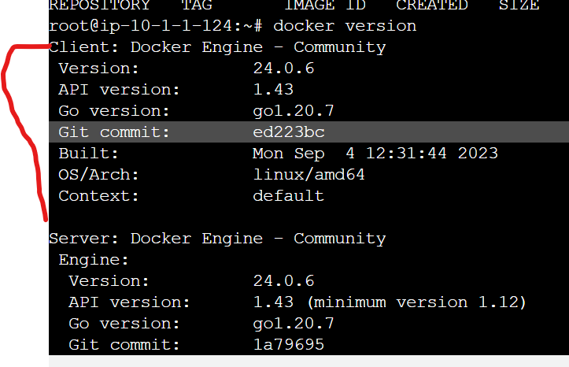

7.Docker client and docker server

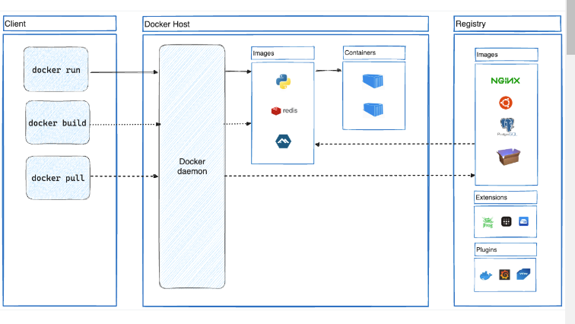

8.docker client:

he Docker client ( docker ) is the primary way that many Docker users interact with Docker. When you use commands such as docker run , the client sends these commands to dockerd , which carries them out. The docker command uses the Docker API. The Docker client can communicate with more than one daemon.

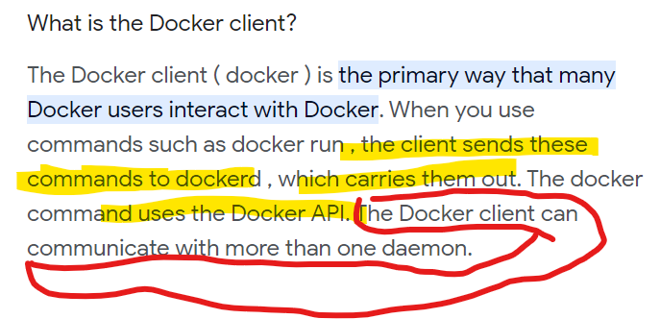

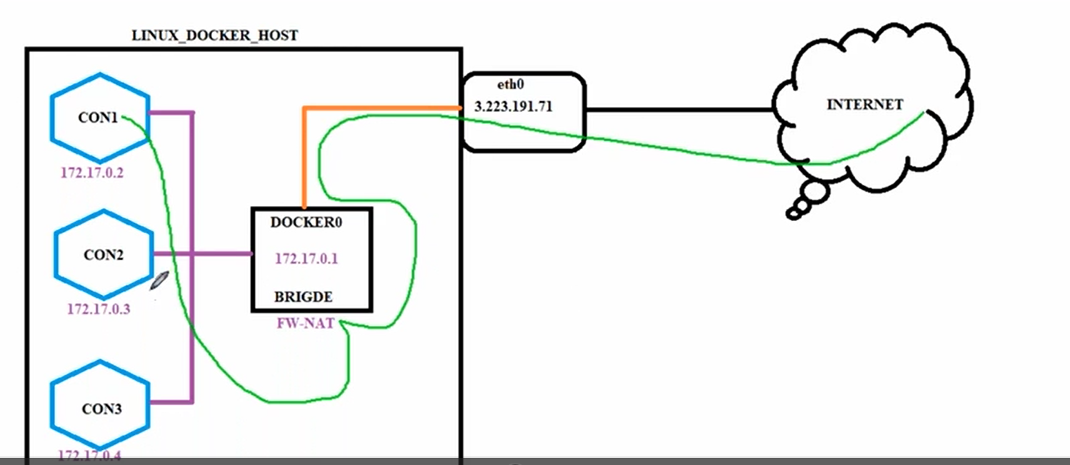

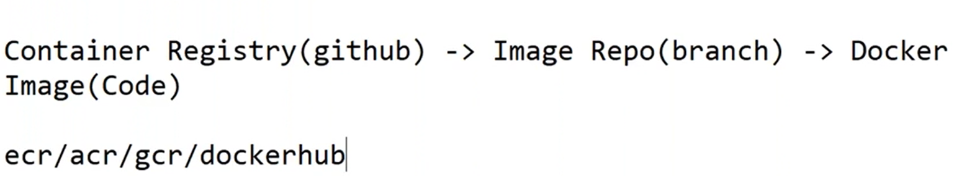

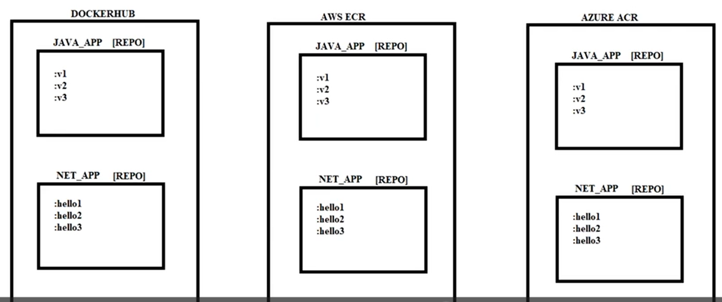

Docker registry creation:

Step1

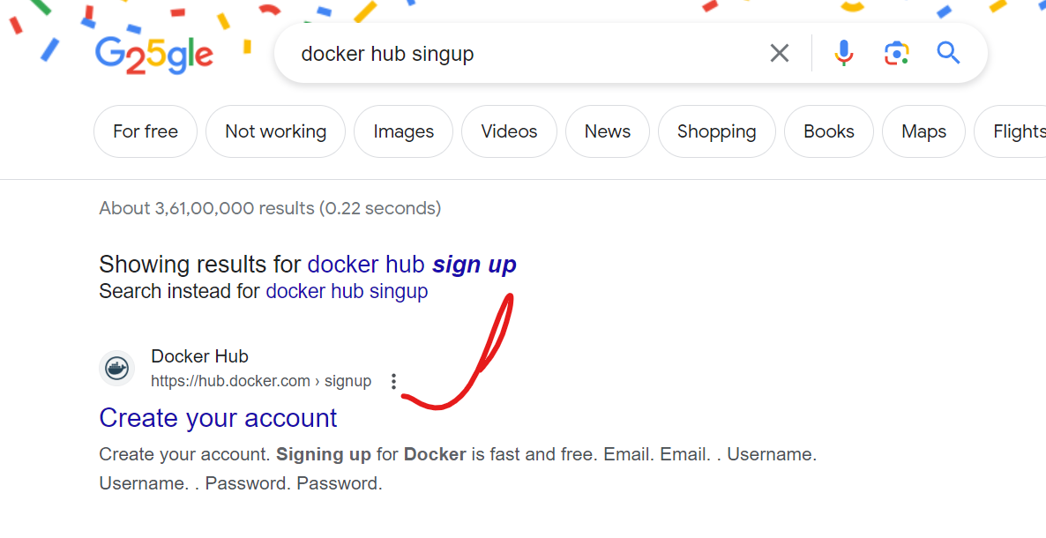

Select sign up docker and create it and sign in

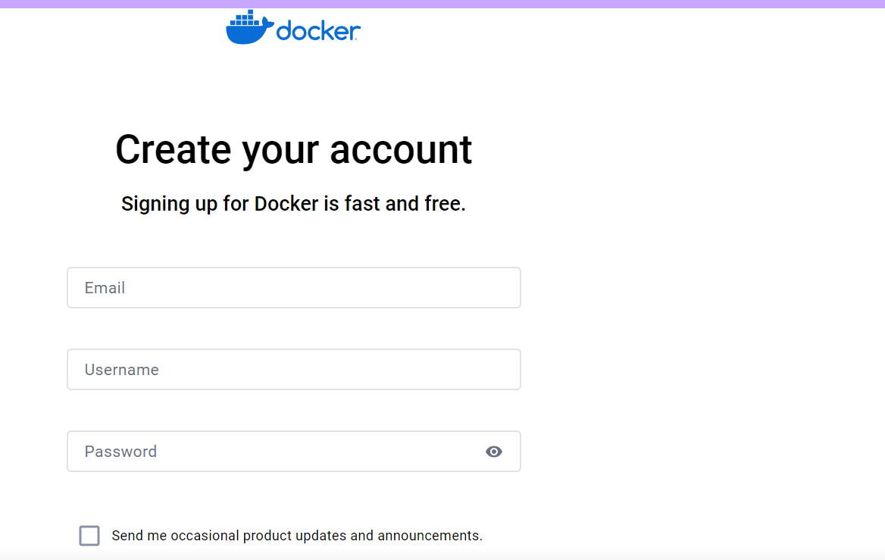

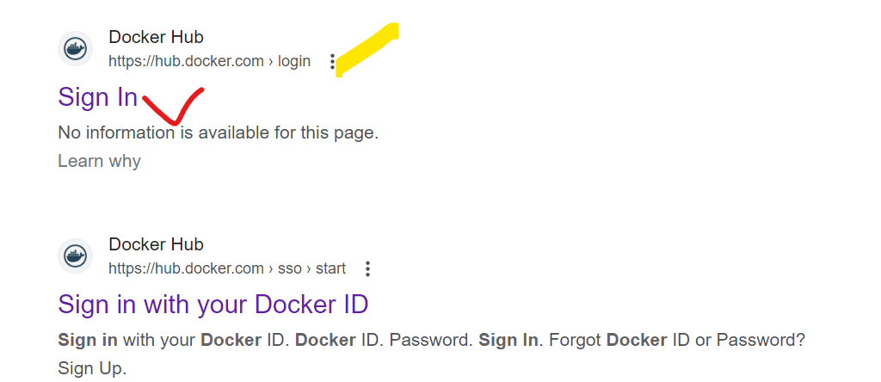

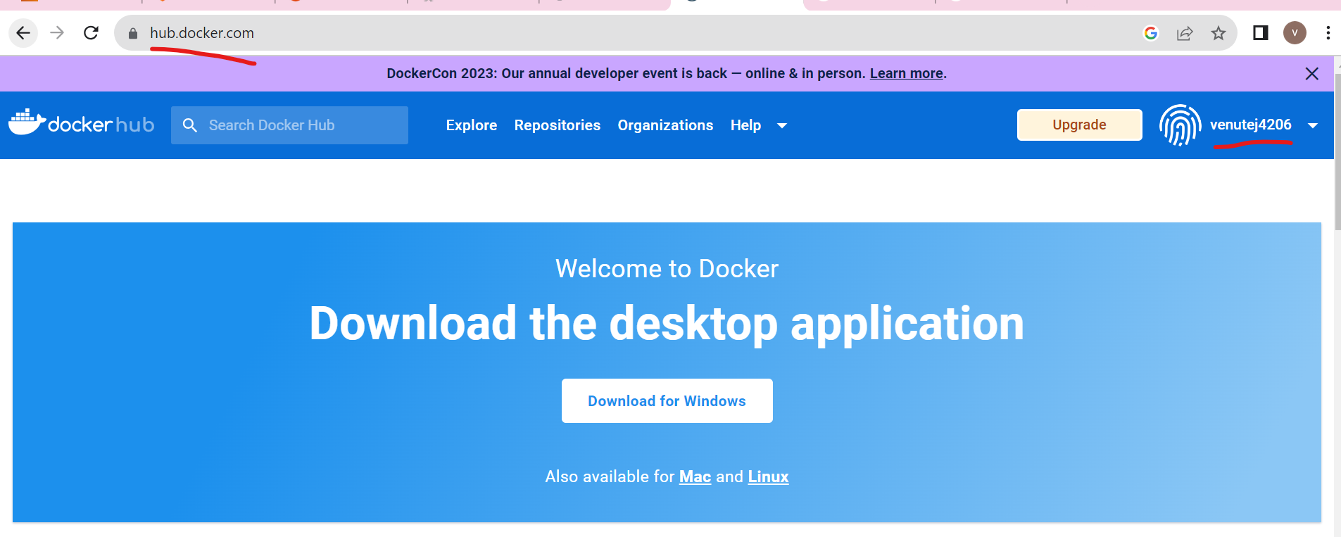

Venutej4206

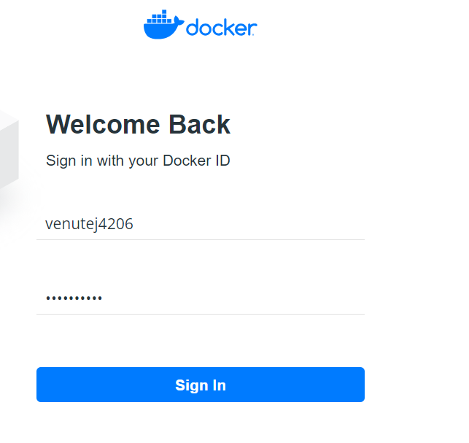

Sign in up account

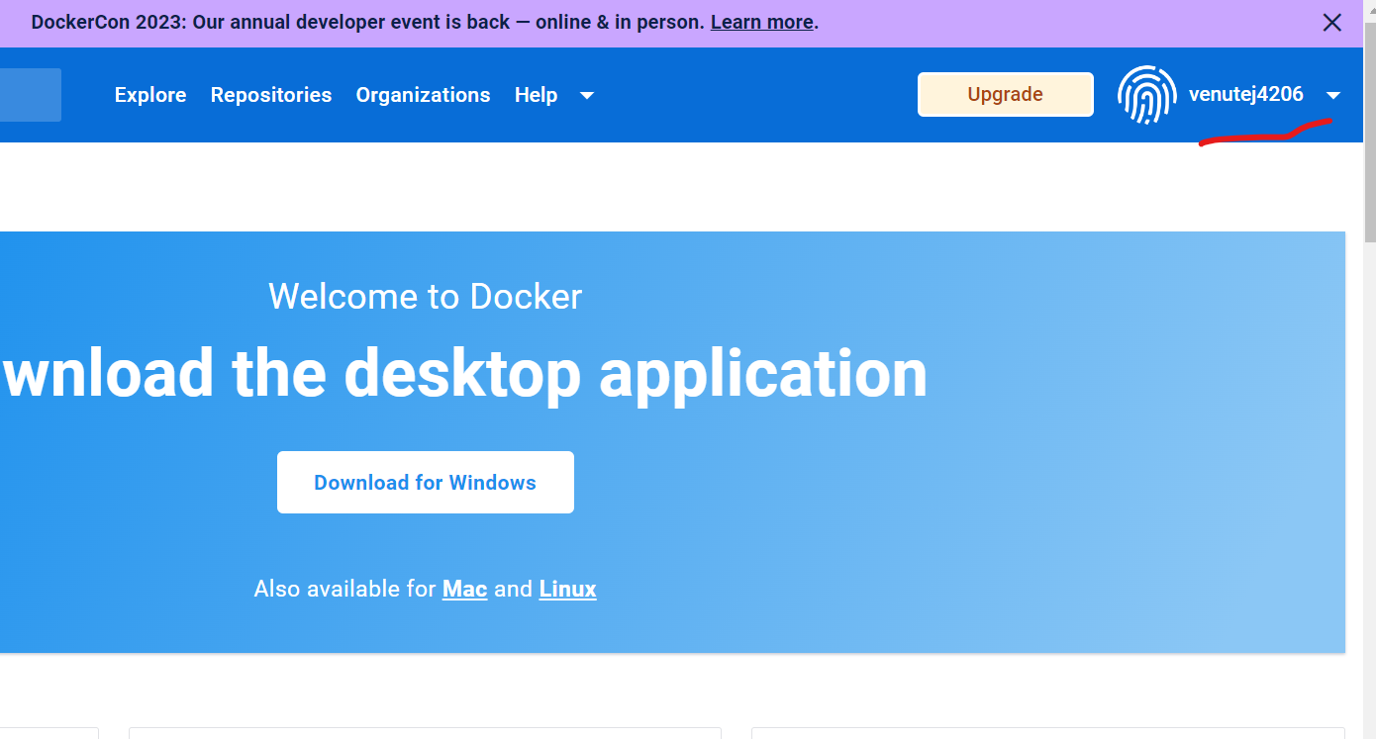

Create repository

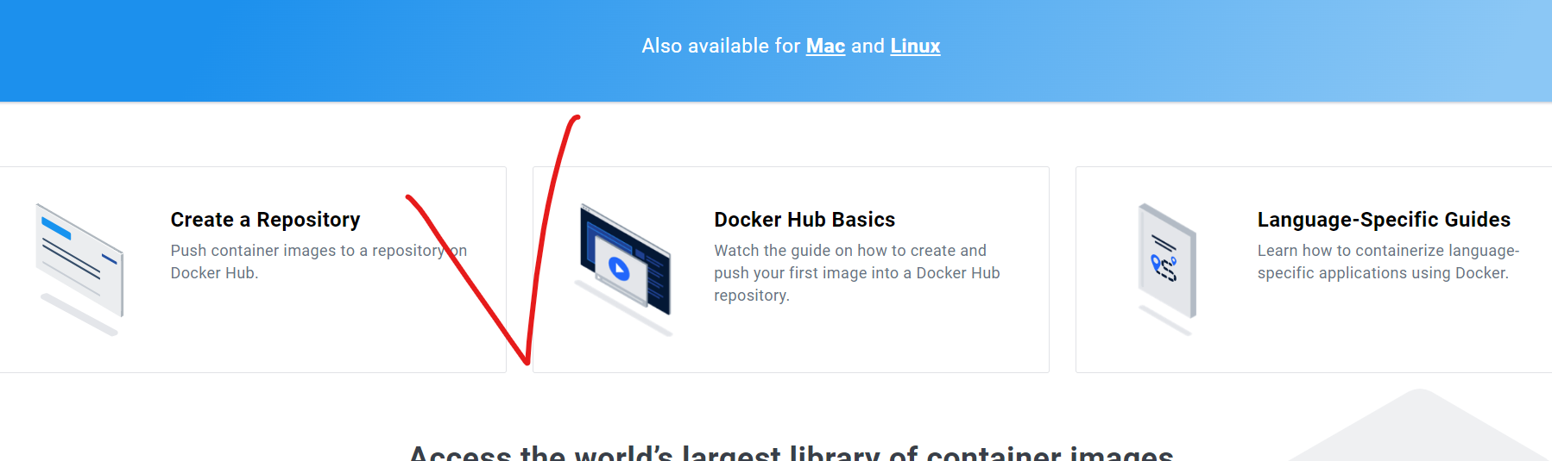

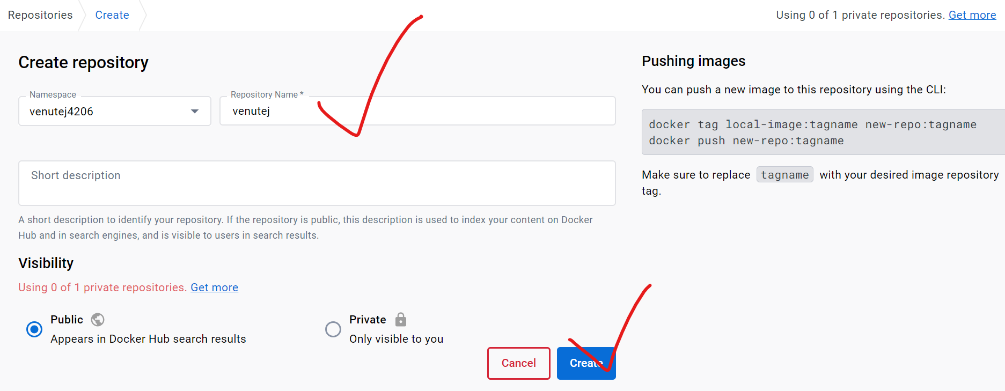

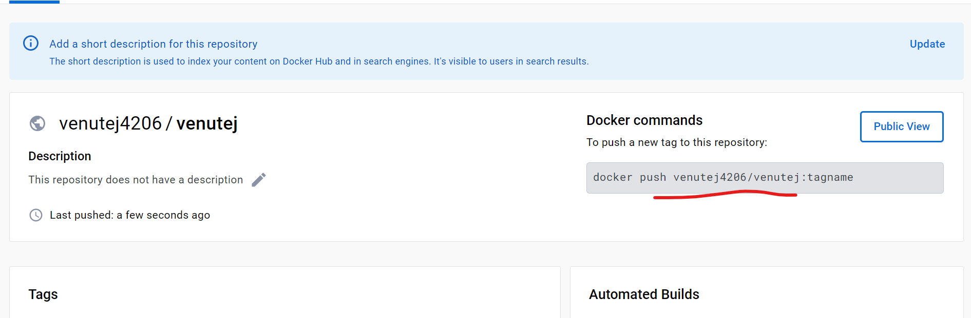

How to pull images public from docker hub

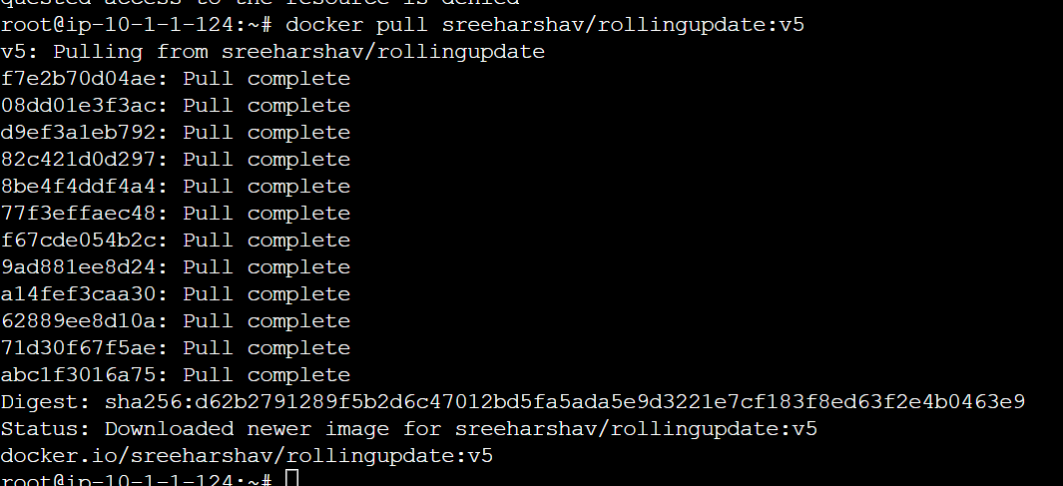

root@ip-10-1-1-124:~# docker pull sreeharshav/rollingupdate:v5

docker images check

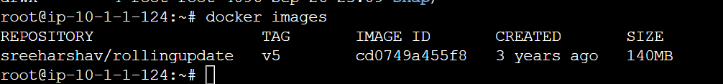

root@ip-10-1-1-124:~# docker inspect con1

[

{

"Id": "c75b180bfbb48d7667049920cf8b59b6feed45c5595847bd6d03e73aca80363a",

"Created": "2023-09-27T01:28:21.011699901Z",

"Path": "nginx",

"Args": [

"-g",

"daemon off;"

],

"State": {

"Status": "running",

"Running": true,

"Paused": false,

"Restarting": false,

"OOMKilled": false,

"Dead": false,

"Pid": 9892,

"ExitCode": 0,

"Error": "",

"StartedAt": "2023-09-27T01:28:21.627993779Z",

"FinishedAt": "0001-01-01T00:00:00Z"

},

"Image": "sha256:cd0749a455f884918786b796c00e7c248419c1b8625019ede444fab1a41a7102",

"ResolvConfPath": "/var/lib/docker/containers/c75b180bfbb48d7667049920cf8b59b6feed45c5595847bd6d03e73aca80363a/resolv.conf",

"HostnamePath": "/var/lib/docker/containers/c75b180bfbb48d7667049920cf8b59b6feed45c5595847bd6d03e73aca80363a/hostname",

"HostsPath": "/var/lib/docker/containers/c75b180bfbb48d7667049920cf8b59b6feed45c5595847bd6d03e73aca80363a/hosts",

"LogPath": "/var/lib/docker/containers/c75b180bfbb48d7667049920cf8b59b6feed45c5595847bd6d03e73aca80363a/c75b180bfbb48d7667049920cf8b59b6feed45c5595847bd6d03e73aca80363a-json.log",

"Name": "/con1",

"RestartCount": 0,

"Driver": "overlay2",

"Platform": "linux",

"MountLabel": "",

"ProcessLabel": "",

"AppArmorProfile": "docker-default",

"ExecIDs": null,

"HostConfig": {

"Binds": null,

"ContainerIDFile": "",

"LogConfig": {

"Type": "json-file",

"Config": {}

},

"NetworkMode": "default",

"PortBindings": {},

"RestartPolicy": {

"Name": "no",

"MaximumRetryCount": 0

},

"AutoRemove": false,

"VolumeDriver": "",

"VolumesFrom": null,

"ConsoleSize": [

20,

146

],

"CapAdd": null,

"CapDrop": null,

"CgroupnsMode": "private",

"Dns": [],

"DnsOptions": [],

"DnsSearch": [],

"ExtraHosts": null,

"GroupAdd": null,

"IpcMode": "private",

"Cgroup": "",

"Links": null,

"OomScoreAdj": 0,

"PidMode": "",

"Privileged": false,

"PublishAllPorts": false,

"ReadonlyRootfs": false,

"SecurityOpt": null,

"UTSMode": "",

"UsernsMode": "",

"ShmSize": 67108864,

"Runtime": "runc",

"Isolation": "",

"CpuShares": 0,

"Memory": 0,

"NanoCpus": 0,

"CgroupParent": "",

"BlkioWeight": 0,

"BlkioWeightDevice": [],

"BlkioDeviceReadBps": [],

"BlkioDeviceWriteBps": [],

"BlkioDeviceReadIOps": [],

"BlkioDeviceWriteIOps": [],

"CpuPeriod": 0,

"CpuQuota": 0,

"CpuRealtimePeriod": 0,

"CpuRealtimeRuntime": 0,

"CpusetCpus": "",

"CpusetMems": "",

"Devices": [],

"DeviceCgroupRules": null,

"DeviceRequests": null,

"MemoryReservation": 0,

"MemorySwap": 0,

"MemorySwappiness": null,

"OomKillDisable": null,

"PidsLimit": null,

"Ulimits": null,

"CpuCount": 0,

"CpuPercent": 0,

"IOMaximumIOps": 0,

"IOMaximumBandwidth": 0,

"MaskedPaths": [

"/proc/asound",

"/proc/acpi",

"/proc/kcore",

"/proc/keys",

"/proc/latency_stats",

"/proc/timer_list",

"/proc/timer_stats",

"/proc/sched_debug",

"/proc/scsi",

"/sys/firmware"

],

"ReadonlyPaths": [

"/proc/bus",

"/proc/fs",

"/proc/irq",

"/proc/sys",

"/proc/sysrq-trigger"

]

},

"GraphDriver": {

"Data": {

"LowerDir": "/var/lib/docker/overlay2/82d34b43d4582da670b89e2e0d6b0450c6fd35d0b6b0414c78dcb40b872f64c4-init/diff:/var/lib/docker/overlay2/6d5d86393356d1fbdfaf16d3809a41ca0ff244466c52d3a39436a8b90ffb4ce7/diff:/var/lib/docker/overlay2/a6c8aafa28bb44cf067aab3f71dbdb931b4111d932fad064d704a7ab26f5c53e/diff:/var/lib/docker/overlay2/cca4cfe58b2fda67380823e8e2b981b53c2dceb4315d904efe69e500f503ce3b/diff:/var/lib/docker/overlay2/acc37f3f904a2a01baeebd4e8feacbc73b3ea3dda07c131af91e90f9be4a217e/diff:/var/lib/docker/overlay2/4d5bd0cc4dd76ee66a865f2b92135ab6f1b300931bcfb8e88ba2f7f7cfcb9e23/diff:/var/lib/docker/overlay2/f0918b8c867bd2ecebf8b21c427ba69089c59b762b787925d1501892ae1b5469/diff:/var/lib/docker/overlay2/3a283dcbc2a3160ad67720c5574ab6bbed43ef00b5b3555fddef43758b57edcf/diff:/var/lib/docker/overlay2/84613258fe33854f1e7efc9e5ba15a609113a3b8054553e053668c6ae37310f2/diff:/var/lib/docker/overlay2/b5d13c05f8ceb4b39839a52bdd359f4d229240846b550bba7c5a0aa8f656c333/diff:/var/lib/docker/overlay2/8f2ce2707f5f9b95eea4af5fbfab864fec03260561f807cf80d427e1384b380e/diff:/var/lib/docker/overlay2/ec5e12ded24488694d878c330f5409c1bb398c0b2b1c5aa5dd2d10f9c5c5cdb9/diff:/var/lib/docker/overlay2/c45942ff20795007bc70bd66568b763c5a452bf83a6b494932ff0e037da64fdc/diff",

"MergedDir": "/var/lib/docker/overlay2/82d34b43d4582da670b89e2e0d6b0450c6fd35d0b6b0414c78dcb40b872f64c4/merged",

"UpperDir": "/var/lib/docker/overlay2/82d34b43d4582da670b89e2e0d6b0450c6fd35d0b6b0414c78dcb40b872f64c4/diff",

"WorkDir": "/var/lib/docker/overlay2/82d34b43d4582da670b89e2e0d6b0450c6fd35d0b6b0414c78dcb40b872f64c4/work"

},

"Name": "overlay2"

},

"Mounts": [],

"Config": {

"Hostname": "c75b180bfbb4",

"Domainname": "",

"User": "",

"AttachStdin": false,

"AttachStdout": true,

"AttachStderr": true,

"ExposedPorts": {

"80/tcp": {}

},

"Tty": false,

"OpenStdin": false,

"StdinOnce": false,

"Env": [

"PATH=/usr/local/sbin:/usr/local/bin:/usr/sbin:/usr/bin:/sbin:/bin",

"NGINX_VERSION=1.15.9-1~stretch",

"NJS_VERSION=1.15.9.0.2.8-1~stretch"

],

"Cmd": [

"nginx",

"-g",

"daemon off;"

],

"Image": "sreeharshav/rollingupdate:v5",

"Volumes": null,

"WorkingDir": "",

"Entrypoint": null,

"OnBuild": null,

"Labels": {

"maintainer": "NGINX Docker Maintainers <docker-maint@nginx.com>"

},

"StopSignal": "SIGTERM"

},

"NetworkSettings": {

"Bridge": "",

"SandboxID": "872852f105e6862a067cc2bca5518ea9b440c1758926627c2348748caa5306a9",

"HairpinMode": false,

"LinkLocalIPv6Address": "",

"LinkLocalIPv6PrefixLen": 0,

"Ports": {

"80/tcp": null

},

"SandboxKey": "/var/run/docker/netns/872852f105e6",

"SecondaryIPAddresses": null,

"SecondaryIPv6Addresses": null,

"EndpointID": "3351431c77136125ed5b666d1e0e7d2da73ba785843009d8890e51a666ad3a5c",

"Gateway": "172.17.0.1",

"GlobalIPv6Address": "",

"GlobalIPv6PrefixLen": 0,

"IPAddress": "172.17.0.2",

"IPPrefixLen": 16,

"IPv6Gateway": "",

"MacAddress": "02:42:ac:11:00:02",

"Networks": {

"bridge": {

"IPAMConfig": null,

"Links": null,

"Aliases": null,

"NetworkID": "6d61dca6bf69aa814e2abd05b0fa9124558682a3caa7b7dbe95f588e903c9d2f",

"EndpointID": "3351431c77136125ed5b666d1e0e7d2da73ba785843009d8890e51a666ad3a5c",

"Gateway": "172.17.0.1",

"IPAddress": "172.17.0.2",

"IPPrefixLen": 16,

"IPv6Gateway": "",

"GlobalIPv6Address": "",

"GlobalIPv6PrefixLen": 0,

"MacAddress": "02:42:ac:11:00:02",

"DriverOpts": null

}

}

}

}

]

Docker ps running container

docker ps -a deleted container

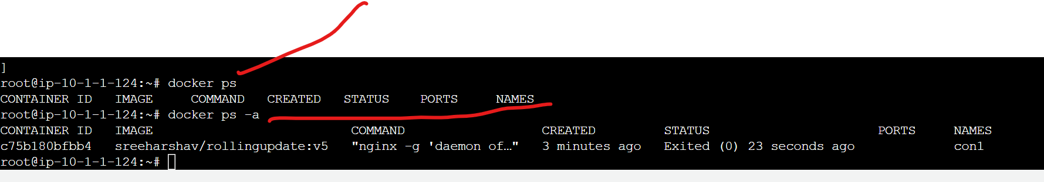

If you’re not provide the dit directly login to the Container



How to see the hidden container.



How to delete the container

